Sahil Saini Salaria
Roll No 11
Reg No 180905048

Q1

# import sys
# sys.setrecursionlimit(1500)

class setGenerator:
arr=[]
all_subsets=[]
def get_array_input(self,N):
print("Enter "+str(N)+" numbers:")
for i in range(N):
ele=int(input())
self.arr.append(ele)

def helper(self,i,subsets):
# self.all_subsets.append(subsets)
print(subsets)
for ele in range(i,len(self.arr)):
subsets.append(self.arr[ele])
self.helper(ele+1,subsets)
subsets.pop()

def get_unique_sets(self):
subsets=[]
self.helper(0,subsets)
# print(self.all_subsets)

my_obj=setGenerator()
N=int(input("Enter N:"))
my_obj.get_array_input(N)

print("Subsets are:")
my_obj.get_unique_sets()

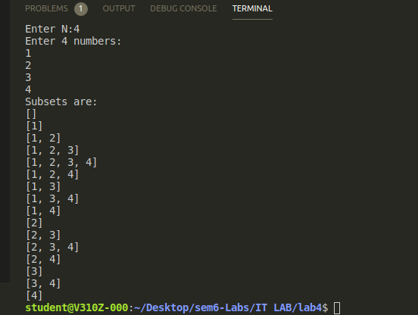

Q2

class myClass:
arr=[]
def get_input(self,N):
print("Enter "+str(N)+" values:")
for i in range(N):
ele=int(input())
self.arr.append(ele)

def get_two_numbers(self,target_sum):
for i in range(len(self.arr)):
for j in range(i+1,len(self.arr)):
if self.arr[i]+self.arr[j]==target_sum:
return (i,j)
return None

myobj=myClass()
N=int(input("Enter the value of N:"))
myobj.get_input(N)

target_sum=int(input("Enter the target sum:"))

indices=myobj.get_two_numbers(target_sum)

if indices==None:
print("No pair found!")
else:
print(indices[0],indices[1])

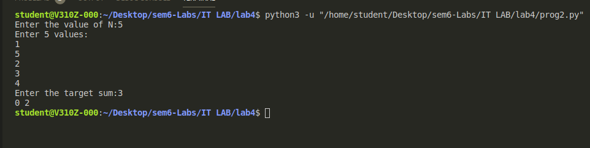

Q3

class PowClass:
x=0
n=0
pow_var=1
def get_input(self):
print("Enter value of x:")
self.x=int(input())
print("Enter value of n:")
self.n=int(input())

def find_power(self):
for i in range(self.n):
self.pow_var=self.pow_var*self.x
return self.pow_var

my_obj=PowClass()
my_obj.get_input()
pow_var=my_obj.find_power()
print(str(my_obj.x)+"^"+str(my_obj.n)+" = "+str(pow_var))

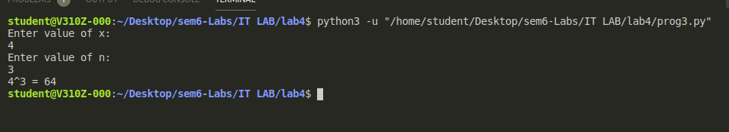

Q4

class myClass:
my_string=""

def get_String(self):
self.my_string=input("Enter the string:")

def print_String(self):
new_str=self.my_string.upper()
print(new_str)

my_obj=myClass()

my_obj.get_String()
my_obj.print_String()

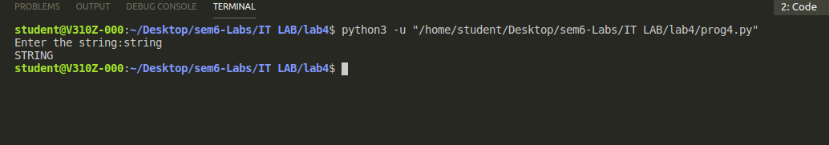

ADDITIONALS

Additional 1

class Validity:

def check_validity(self,exp_input):
stack=[]
exp_arr=['(','{','[']

for ele in exp_input:
if ele in exp_arr:
stack.append(ele)
elif (ele==')' and stack[len(stack)-1]!='(') or (ele=='}' and stack[len(stack)-1]!='{') or (ele==']' and stack[len(stack)-1]!='['):
return False
else:
stack.pop()

if len(stack) !=0:
return False

return True

exp_input=input("Enter the expression:")

my_obj=Validity()

if my_obj.check_validity(exp_input):
print("Valid Expression!")
else:
print("Invalid Expression!")

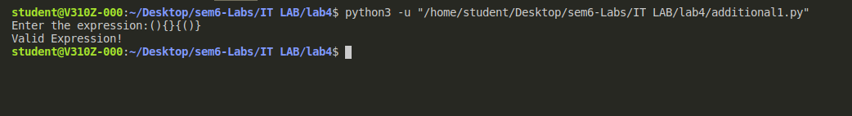

Additional 2

